2024-2025

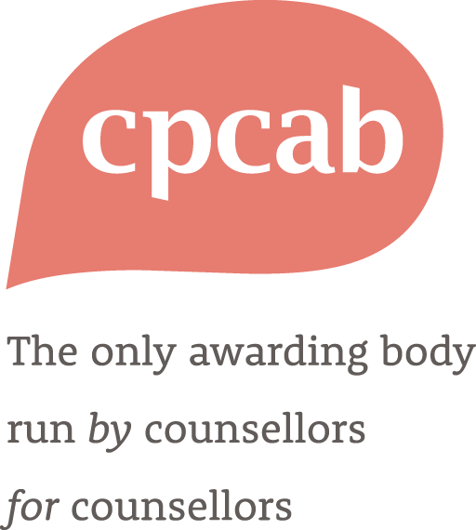

Application for CPD Endorsement



|  |  |
| --- | --- |
| Contents | Page |
| 1. Contact details | 3 |
| 1. Meeting CPCAB requirements | 4 |
| 1. Workshop content/design (Specification) | 7 |
| 1. Declaration of meeting CPCAB requirements | 8 |

**Part 1: Contact details and proposed tutor team**

|  |  |
| --- | --- |
| Applicant name and position: |  |
| Organisation name: |  |
| Are you a registered CPCAB centre?  If Yes, please state your centre number: | YES/NO |
| Address for correspondence:  Address of the training venue (if different): |  |
| Telephone: |  |
| e-mail: |  |
| Website: |  |
| Name of finance contact: |  |
| Address of finance contact (if different from above): |  |
| Telephone (finance): |  |
| e-mail (finance): |  |

**Part 2: Meeting CPCAB requirements**

CPCAB has to ensure that the CPD courses you provide are delivered in accordance with our requirements.

When you are sure you can meet the requirements, please tick the boxes on the right and sign the declaration at the end. It is the organisation’s responsibility to provide documentary evidence if requested.

Once this document is signed and approved it constitutes a written agreement between your organisation and CPCAB. CPCAB may withdraw approval if there is evidence that these requirements are not being met.

Please see [CPCAB website](http://www.cpcab.co.uk/public_docs/guidelines-to-cpd-endorsement) for guidelines on how to complete this application.

|  |  |  |  |
| --- | --- | --- | --- |
| **2.1 CPCAB requirements** | | | **Please tick** |
| 2.1.1 | **I confirm that:**   * the staff delivering the CPD training are suitably qualified and will not bring the training, CPCAB or the training organisation into disrepute * that staff delivering the CPD will work to the principles of a named ethical framework for professional practice (please specify) | | ***□***  ***□*** | |
| 2.1.2 | **I confirm that the organisation will take responsibility for ensuring that participants have suitable prior training or experience for the CPD course being offered.** | | ***□*** | |
| 2.1.3 | **I confirm that the organisation complies with the Equality Act 2010 including:**   * ensuring that participant diversity, equality of opportunity and anti-discrimination legislation is taken account of in course promotion, pre-course assessment, the design of course materials and training delivery * confirming the learning resources are appropriate to the curriculum. * that the organisation uses premises that provide access for all participants in accordance with relevant legislation. | | ***□***  ***□ □*** | |
| 2.1.4 | | **I understand that it is the responsibility of the organisation to:**   * have a workforce of appropriate size and competence to deliver the CPD workshop/course as required by CPCAB * have sufficient staffing, financial and other resources to effectively and efficiently deliver the CPD workshop/course as required by CPCAB * the organisation will take all reasonable steps to protect the interests of participants in the event of a workshop/course being withdrawn, interrupted or otherwise discontinued * publish accurate information on the organisation’s website including: target group/aim and learning outcomes/cost/dates/any additional requirements   **Organisations may be required to provide additional evidence of the organisation’s resources and contingency planning if requested by CPCAB.** | ***□***  ***□***  ***□***  ***□*** |
| 2.1.5 | | **I confirm that the centre** complies with data protection legislation (General Data Protection Regulations). [1] | ***□*** |
| 2.1.6 | | **I agree to:**   * publish minimum attendance requirements * monitor participant attendance. | ***□***  ***□*** |
| 2.1.7 | | **I confirm that the centre will:**   * commit to work to the competencies outlined in the [CPCAB Quality Framework for Online Delivery](https://www.cpcab.co.uk/public_docs/cpcab-quality-framework-for-online-delivery) for any workshops delivered online or in a blended format | ***□*** |
| 2.1.8 | | **I understand:**   * CPCAB will aim to visit an early delivery of a workshop/course by the organisation in order to quality assure the delivery of that training and verify attendance | ***□*** |
| 2.1.9 | | **I understand it is the responsibility of the organisation:**   * to advertise the location of each training session and to document and manage the respective roles and responsibilities of each partner where the organisation is in a partnership arrangement with other organisations. | ***□*** |
| 2.1.10 | | **I agree**   * that the organisation will operate a complaints procedure for the benefit of participants * that the organisation will offer and publish a cancellation policy * that the organisation will publish payment arrangements/options. | ***□***  ***□***  ***□*** |
| 2.1.11 | | **I agree**   * to issue CPD certificates to participants who successfully complete the CPD workshop/course * to offer replacement certificates for up to 1 year after the end of the workshop/course * to only use the CPCAB logo on endorsed CPCAB workshops/courses. |  |
| 2.1.12 | | **For continued endorsement I agree:**   * to collect participant evaluations of each delivery and submit them to CPCAB when requested. (At least once per year) * to provide CPCAB with details and dates of each CPD workshop/course they intend to run. | ***□*** |

**Part 3: Work content/design (Specification)**

Please provide the following information. If you are applying for multiple workshops, please complete a new specification for each.

|  |  |
| --- | --- |
| **CPD title:** |  |
| **Description of CPD:**   * *Workshop* * *Seminar* * *Webinar* * *Conference* * *On-line activity* * *Lecture* * *Short course* * *Other (please specify)* |  |
| **Description of the overall aims and objectives of the CPD workshop/course:** |  |
| **Summary of expected Learning Outcomes:** |  |
| **Length of workshop/course:** |  |
| **Target participants:**  ***(****eg minimum age, required prior qualifications/experience)* |  |
| **Minimum and maximum group size:** |  |
| **Minimum attendance requirement:** |  |
| **Description of any additional requirements** *(eg pre-course reading, entry requirements, homework)* |  |

|  |  |
| --- | --- |
| **Dates of proposed workshop/course:** |  |
| **Name(s) of trainer(s) delivering the CPD workshop/course including relevant qualifications/experience:** |  |
| **CPCAB external visit arrangements:**  (*to be agreed during discussions with CPCAB)* |  |
| **Any additional information regarding the workshop/course:** |  |
| **Any other requirements for Annual Certificate for CPCAB Endorsed CPD courses** (*eg candidate evaluations)* |  |
| **Organisation CPD participant fee:** |  |
| **CPCAB per annum fee:** | Please tick the appropriate band  1-10 hours - £113 ***□***  11-20 hours - £165 ***□***  21-30 hours - £224 ***□*** |

**Part 4: Centre declaration**

**I confirm that all the information given in Parts 1, 2, and 3 is accurate: *□***

**I confirm that the centre will take all reasonable steps to comply with these requirements for CPCAB endorsement and understand that CPCAB may be obliged to impose reasonable and appropriate sanctions[2] if these requirements are not met: *□***

Signed (on behalf of the centre):

Name (please print):

Position: Date:

1. Your data will be held in accordance with CPCAB’s [Data Protection Policy](http://www.cpcab.co.uk/public_docs/data-protection-policy?search=data%20protection%20policy).
2. Please see [CPCAB policies](https://www.cpcab.co.uk/centres/documents) on Sanctions, Malpractice and Maladministration, Conflict of Interest, Complaints and Whistleblowing.